**Introduction to JavaScript & Things It Can Do -** [React Dojo](https://akbar-alizadeh5.medium.com/?source=post_page-----fca2d0d193b0--------------------------------) Jul 16, 2022

Welcome to the series of learning JavaScript. Today’s article is a short introduction to JavaScript and some examples of what JavaScript can do.

**What is JavaScript?**

JavaScript is the world’s **most popular programming language**.

JavaScript is the **Programming Language** for the Web.

JavaScript can update and change both **HTML** and **CSS.**

JavaScript can **calculate**, **manipulate** and **validate** data.

These are some examples of **what JavaScript can do**:

**1. JavaScript Can Change HTML Content**

One of many JavaScript HTML methods is getElementById().

The example below “finds” an HTML element (with id=” demo”), and changes the element content (innerHTML) to “Hello JavaScript”:

**Example**

Code: document.getElementById(“demo”).innerHTML = “Hello JavaScript”;

Before clicking the button “Click Me!”:

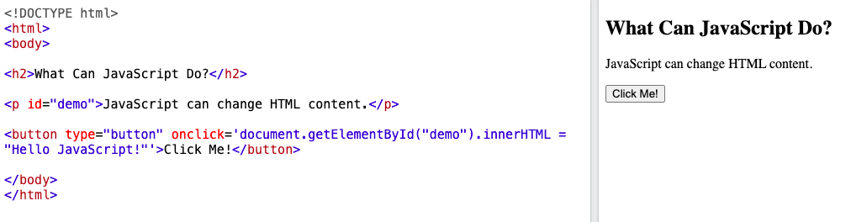

After clicking the button:

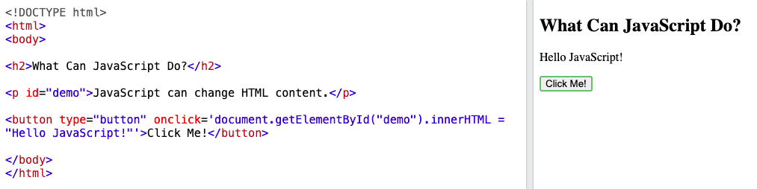

The content changed.

*Note: JavaScript accepts **both** double(“ “) and single(‘ ‘) quotes.

**2. JavaScript Can Change HTML Attribute Values**

In this example JavaScript changes the value of the src (source) attribute of a <img> tag:

When you click to turn on:

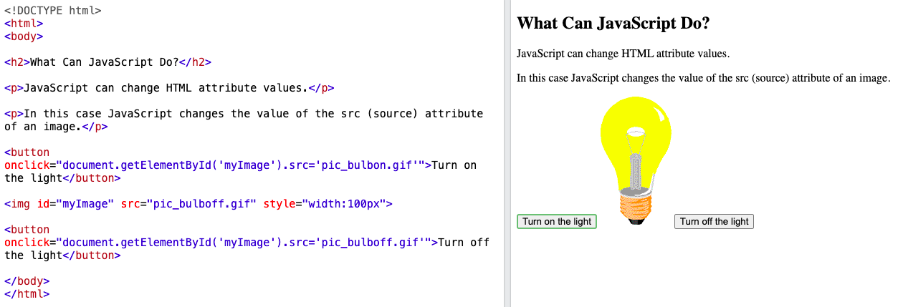

The light turned on.

When you click to turn off:

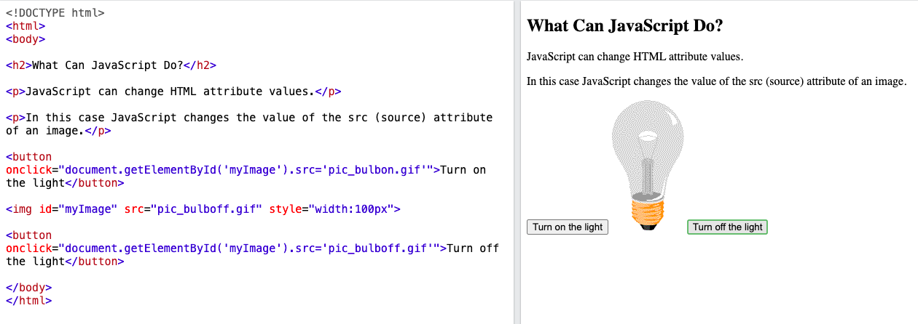

The light turned off.

**3. JavaScript Can Change HTML Styles (CSS)**

Changing the style of an HTML element is a variant of changing an HTML attribute:

**Example**

Code: document.getElementById(“demo”).style.fontSize = “35px”;

Before clicking the button:

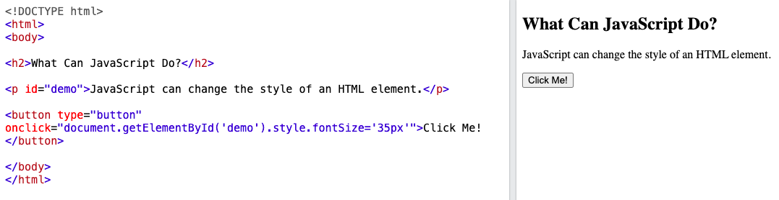

After clicking the button:

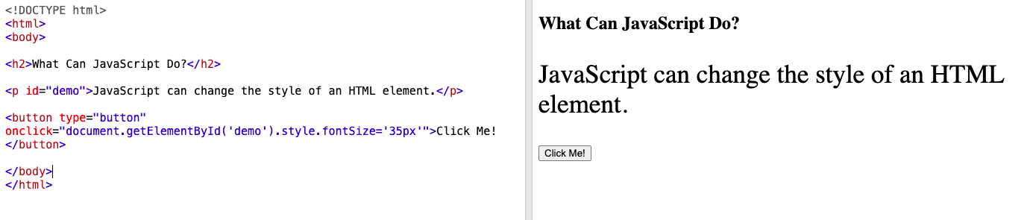

The style changed.

**4. JavaScript Can Hide HTML Elements**

Hiding HTML elements can be done by changing the display style:

**Example**

Code: document.getElementById(“demo”).style.display = “none”;

Before clicking the button:

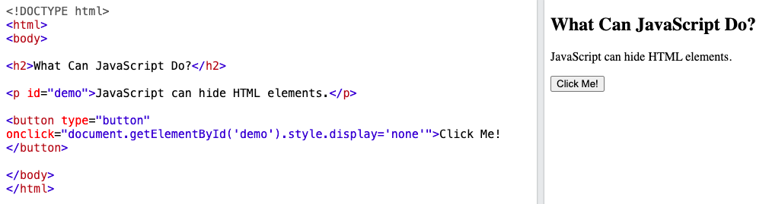

After clicking the button:

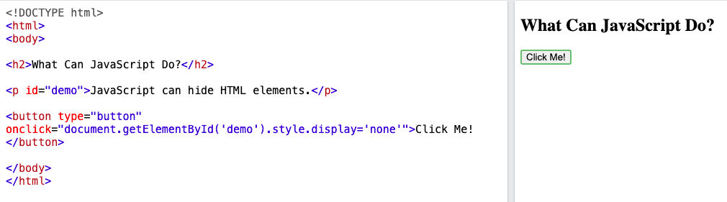

The element hid.

**5. JavaScript Can Show HTML Elements**

Showing hidden HTML elements can also be done by changing the display style:

**Example**

Code: document.getElementById(“demo”).style.display = “block”;

Before clicking the button:

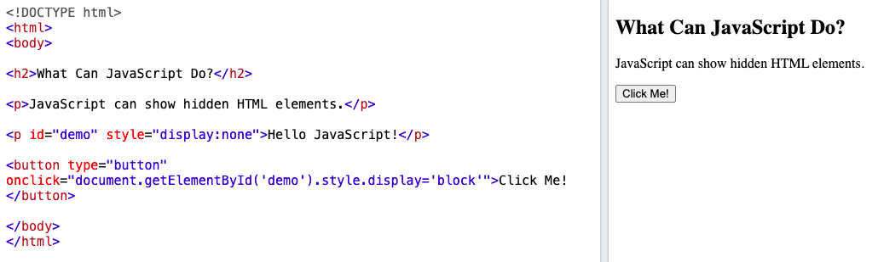

After clicking the button:

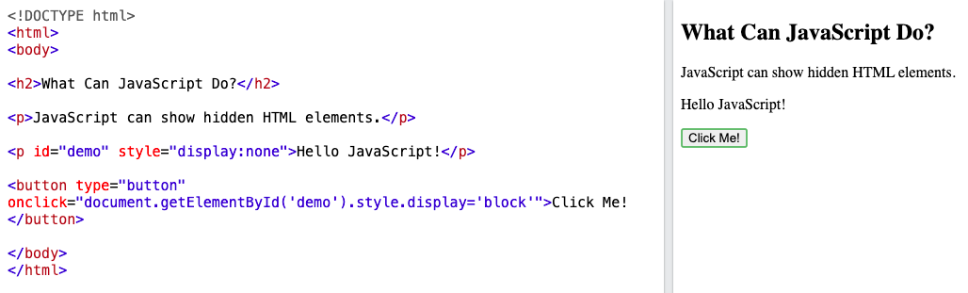

The hidden element showed up.

**Did You Know?**

JavaScript and Java are **completely different** languages, both in concept and design. JavaScript was invented by **Brendan Eich** in 1995 and became an ECMA standard in 1997. ECMA-262 is the official name of the standard. **ECMAScript** is the official name of the language.